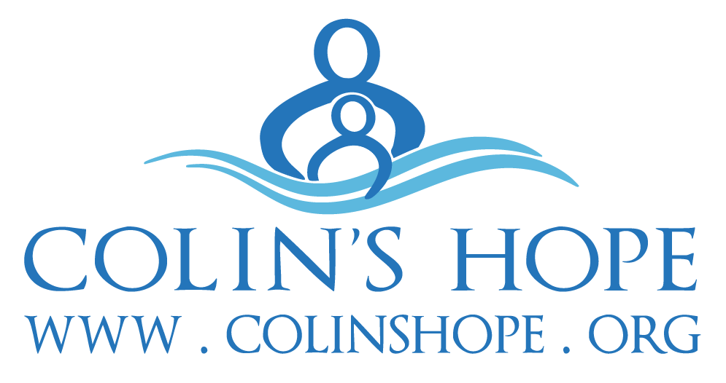
COLIN’S HOPE Best Day Ever Party

Colin’s Hope is a nonprofit whose mission is to raise water safety awareness to prevent children from drowning.
We are excited to announce the Best Day Ever Party to Prevent Drowning, on Saturday, April 14, 2018 at the beautiful Villa Del Lago on Lake Travis. The party is the perfect venue for Colin’s Hope to kickoff our 2018 Water Safety Awareness campaign. We are currently seeking sponsors and guests and hope you will join with us.
Best Day Ever Party GOALS:
- Provide a stellar experience while highlighting our mission and showcasing sponsors.
- Raise essential funds ($150,000 goal) for Colin’s Hope to continue year round water safety education and drowning prevention awareness programs.

Best Day Ever Party DETAILS: Exclusive Invitation List; limited to 225 guests.
- Stellar view and venue at Villa Del Lago on Lake Travis
- Live music (artist TBD)
- Spectacular food and drinks
- Kendra Scott Trunk Show
- Destination raffle packages
- Fund-a-Need Program, and Live auction

WHY SHOULD YOU SUPPORT COLIN’S HOPE?
Last year, 107 Texas children lost their lives to a fatal drowning, while many more survived a non­fatal drowning with life-altering repercussions. Texas leads the nation in the number of childhood drownings and drowning is the number 1 cause of accidental death for children under 5, yet drowning is preventable. So far this year, we know 78 Texas children have lost their lives to a fatal drowning. We, as a society, need to continue to do more to prevent these tragedies.
Colin’s Hope was founded in 2008 to honor Colin Holst, a 4-year-old boy, who drowned in an Austin public lifeguarded pool. In our short history, we have become a leader in local, state and National drowning prevention efforts. Our programs have been proven to increase children’s water safety knowledge and improve their swimming skills. But we can’t do it without help. We need supporters like you to invest in our work so that we can make an even bigger impact on children and families to prevent drowning. Thank you for your consideration and, as Colin used to say, let’s make it “the Best Day Ever!”.

Best Day Ever Party SPONSOR LEVELS
Through event sponsorship, your company can impact an influential audience while having a “hands on” interaction at the event. This is a great way to demonstrate your company’s investment in the community and partner with a stellar organization. Sponsors of the Colin’s Hope Best Day Ever Party will help Colin’s Hope fund swim safety programs that increase water safety awareness to prevent drowning.

Best Day Ever Party Title Sponsor ­ $20,000 (1 sponsor)
Recognition as Title sponsor
Opportunity to speak during program/auction
25 tickets and reserved seating for dinner and the program/auction
Customized cocktail napkins printed with sponsor logo
Recognition on event signage and program slideshow
Recognition in invitations and save the date
Recognition on event social media and in any press releases
Recognition and logo on Colin’s Hope homepage
Three month placement on the back of the Colin’s Hope vehicle
Product placement in the party swag bags and logo on the bags

Presenting Sponsor $15,000 (1 sponsor or joint sponsorship)
Recognition as Presenting sponsor
Opportunity to speak during the program/auction
20 tickets and reserved seating for dinner and the program/auction
Recognition on event signage and program slideshow
Recognition in invitations and save the date
Recognition on event social media and in any press releases
Recognition and logo on Colin’s Hope website
Two month placement on the back of the Colin’s Hope vehicle
Product placement in the party swag bags and logo on the bags

Food and Beverage Sponsor $10,000 (SOLD, no longer available)
Recognition as a Presenting sponsor of the event
Opportunity to speak at the event.
12 tickets and reserved seating for dinner and the program/auction
Recognition on event signage and program slideshow
Recognition in invitations and save the date
Recognition on event social media and in any press releases
Recognition and logo on Colin’s Hope website
One month placement on the back of the Colin’s Hope vehicle
Product placement in the party swag bags and logo on the bags.

Best Day Ever Party SPONSOR LEVELS

Best Host Ever Sponsors­ $5,000 (multiple available)
Opportunity to underwrite an area of the party: Entertainment, Venue, Lighting and Decor, Program/Auction, Dessert, Cocktail Hour, Swag Bags)
8 tickets and reserved seating for dinner and the program/auction
Verbal recognition during event program
Name/Logo on special, strategically placed signage at event based on area sponsored
Product placement in the party swag bags and logo on the bags
Recognition in invitations and save the date
Recognition on event social media
Recognition on event webpage

Family Circle Sponsor ­ $2,500 (multiple available)

This level is designed for families who have been impacted by drowning

6 tickets and reserved seating for dinner and the program/auction
Customized way to honor your child at the event
Opportunity to put something into the party swag bag if desired
Name/Logo on signage at event
Recognition in invitations and save the date
Recognition on event webpage

Preschool Swim Founders Circle Sponsor ­ $2,500 (multiple available)

This level is designed for those wishing to be in our Founder's Circle - a group focused on helping us expand and sustain our preschool swim program each year
6 tickets and reserved seating for dinner and the program/auction
Opportunity to put something into the party swag bag if desired
Name/Logo on signage at event
Recognition in invitations and save the date
Recognition on event webpage

Water Safety Alliance Sponsors ­ $1500 (multiple available)
4 tickets and reserved seating for dinner and the program/auction
Name/Logo on signage at event
Recognition on event webpage

Drowning Prevention Partner $500 (multiple available)
2 tickets and open seating for dinner and the program/auction
Recognition on event webpage

In-Kind or Auction Item Supporter: We are in need of in-kind support and items for our live auction. Previous auction have included items such as: vacation homes, weekend getaways and personal care packages.

COLIN’S HOPE BEST PARTY EVER­ SPONSOR FORM
Company Name: ________________________________ Company Website: _____________________________
Contact Person: _________________________________ Position: _____________________________________
Mailing Address:_______________________________________________________________________________
Phone: _______________________________ Email Address: _______________________________________
For marketing materials, please email your logo to alissa.magrum@colinshope.org. A vectorized logo is preferred to ensure the highest web and print quality

Sponsorship Level (check one):
- Best Day Ever Party Title $20,000
- Presenting Sponsor $15,000
- Food And Beverage Sponsor $10,000
- Best Host Ever $5,000
- Family Circle $2,500
- Founders Circle $2,500
- Water Safety Alliance $1500
- Drowning Prevention Partner $500
- Life Guard $150 I cannot attend the party but please accept my donation to sponsor 2 children in the Colin’s Hope preschool swim safety program.

- In-Kind or Auction Supporter - description and value of items donated:
_______________________________________
_______________________________________

Please return the completed form to any of the following:
alissa.magrum@colinshope.org
Colin’s Hope
PMB 147
3267 Bee Cave Rd., STE 107
Austin, TX 78746­-6700

Payment Information (credit card):
Name on card: _____________________________________ Expiration Date: _______/_______
Card Number: ______________________________________ CCV (3 digit code): ____________
Signature: ________________________________ Date: ________________________________

For more information about sponsorship of the Colin’s Hope Best Day Ever Party, contact Alissa Magrum at (512) 294-­3910 or alissa.magrum@colinshope.org. To learn more about Colin’s Hope and the work we do, visit www.colinshope.org.

Colin’s Hope is a qualified tax exempt organization, as defined in Section 501(c)(3) of the Internal Revenue Code. Our Federal Tax ID is 30-­0500004. A charitable contribution deduction may be claimed for the amount of a contribution made to Colin’s Hope less the value of goods or services received, if any.

